**<<TaskMitra>>**

A

Project Report

Submitted in partial fulfillment of the requirement for the award of degree of

**Bachelor of Technology**

In

**Information Tecnology**

Submitted to

**RAJIV GANDHI PROUDYOGIKI VISHWAVIDYALAYA,**

**BHOPAL (M.P.)**



**Guided By Submitted By**

Prof. Shahida Khan Kashish Sharma (0827IT211058)

Astha Jain(0827IT211020)

Gaurav Joshi(0827IT211038)

**DEPARTMENT OF INFORMATION TECHNOLOGY**

**ACROPOLIS INSTITUTE OF TECHNOLOGY & RESEARCH,**

**INDORE (M.P.) 452020**

**2023-2024**

**Declaration**

I hereby declared that the work, which is being presented in the project entitled **TaskMitra** partial fulfilment of the requirement for the award of the degree of **Bachelor of Technology**, submitted in the department of Information Technology at **Acropolis Institute of Technology & Research, Indore** is an authentic record of my own work carried under the supervision of “**Prof. Shahida Khan** ”. I have not submitted the matter embodied in this report for award of any other degree.

Kashish Sharma (0827IT211058)

Astha Jain(0827IT211020)

Gaurav Joshi(0827IT211038)

Prof.Shahida Khan

Supervisor

**Project Approval Form**

I hereby recommend that the project <**TaskMitra>** prepared under my supervision by <Kashish Sharma (0827IT211058)**>** be accepted in partial fulfillment of the requirement for the degree of Bachelor of Engineering in Computer Science & Engineering.

<<Prof. Shahida Khan>>

**Supervisor**

Recommendation concurred in 2023-2024

<<Prof. Nivedita Tiwari>>

**Project Incharge**

<<Prof. Deepak Singh Chouhan>>

**Project Coordinator**

**Acropolis Institute of Technology & Research**

**Deparment of Infromation Technology /CSE(DS)/CSE(IoT)**



**Certificate**

The project work entitled **TaskMitra** submitted by **<** **Kashish Sharma (0827IT211058), Astha Jain(0827IT211020), Gaurav Joshi(0827IT211038)>** is approved as partial fulfillment for the award of the degree of Bachelor of Technology in Information Technology by Rajiv Gandhi Proudyogiki Vishwavidyalaya, Bhopal (M.P.).

**Internal Examiner External Examiner**

Name:………………. Name: ……………..

Date: …./…/……….. Date: …./…/………..

**Acknowledgement**

With boundless love and appreciation, we/I would like to extend our/my heartfelt gratitude and appreciation to the people who helped us/me to bring this work in reality. We/I would like to have some space of acknowledgement for them.

Foremost, our/I would like to express our/ my sincere gratitude to our/my supervisor, **Prof. Shahida Khan** whose expertise, consistent guidance, ample time spent and consistent advices that helped us/me to bring this study into success.

To the project in-charge **Prof. Nivedita Tiwari** and project coordinator **Prof. Deepak Singh Chouhan** for their constructive comments, suggestions, and critiquing even in hardship.

To the honourable **Prof. (Dr.) Prashant Lakkadwala**, Head, Department of Information Technology for his favourable responses regarding the study and providing necessary facility.

To the honourable **Dr. S.C. Sharma**, Director, AITR, Indore for his unending support, advises and effort to make possible.

Finally, I/we would like to pay my/our thanks to faculty members and staff of Department of Computer Science & Engineering for their timely help and support.

We/I also like to pay thanks to our/my **parents** for their eternal love, support and prayers.Without them it is not possible.

Kashish Sharma (0827IT211058)

Astha Jain(0827IT211020)

Gaurav Joshi(0827IT211038)

**Abstract**

In today's fast-paced and dynamic work environments, the ability to manage tasks efficiently and stay organized is paramount.This report presents the development and implementation of TaskMitra-"Your Trusted Partner in Streamlining and Managing Tasks with Ease", a versatile task tracking tool designed to enhance project management and task tracking for a wide range of users, including event managers, project managers, institutions, and individuals. The project aimed to create a user-friendly tool that streamlines project organization and task management. The tool will be customizable to suit various workflows, providing the flexibility needed to accommodate different industries and project types.

The report covers the following key aspects:

* The project involved the design and development of TaskMitra, a comprehensive task tracking tool with features for creating and managing projects, assigning tasks, setting deadlines, and tracking progress. The tool caters to multiple user levels and use cases.
* The project was initiated to address the need for an efficient and customizable task tracking tool that can be applied in various contexts, from event management to personal task tracking. It aimed to improve productivity and collaboration.
* By focusing on a user-centered approach, this project seeks to enhance productivity, reduce stress, and foster a more efficient work environment.
* The project involved requirement engineering, technical architecture design, analysis, conceptual design, implementation, and testing. It utilized a methodology that included the development of the tool's technical architecture, user interface, and database.
* The project successfully developed TaskMitra, which offers user-specific views, reminders, time tracking, task templates, task prioritization, analytics, privacy settings, calendar view, budget management, documentation, and resource allocation.
* TaskMitra's findings are significant as it provides a user-friendly solution to streamline project management and task tracking for various purposes. It promotes productivity and collaboration, making it suitable for diverse user groups.
* Through the development of this task tracking tool, we aim to streamline task management, improve clarity in project workflows, and ultimately help individuals and teams achieve their goals with greater ease and effectiveness. This project represents a commitment to innovation, efficiency, and the empowerment of individuals and organizations seeking to excel in their tasks and projects.

**Chapter 1: Introduction**

1.1 Rationale

The TaskMitra project aims to develop a comprehensive task tracking tool to assist teams and individuals in efficiently managing and tracking projects. It is essential for better organization, efficiency, and accountability. It helps manage tasks, prioritize work, and track progress, reducing stress and improving productivity. It's particularly valuable for teams, remote work, and data insights, offering adaptability and continuous improvement opportunities.

1.2 Existing System

Prior to TaskMitra, there were several pre-existing task tracking tool websites available, Some popular ones include:

* Trello:Trello is a user-friendly task tracking tool that uses boards, lists, and cards to organize tasks and projects. It's known for its simplicity and flexibility.
* Asana:Asana is a powerful project management and task tracking tool that offers a wide range of features for teams. It includes task assignment, timelines, and collaboration tools.
* Todoist:Todoist is a simple and intuitive task tracking tool designed for personal task management. It offers features like due dates, priorities, and project organization.
* Jira:Jira is a robust task tracking tool developed for software development and project management. It provides features for agile project management, issue tracking, and customization.
* ClickUp:ClickUp is a task tracking and project management tool that provides features for task management, time tracking, and goal setting.

1.3 Problem Formulation

Problem formulation for a task tracking tool typically involves identifying the challenges and issues that the tool aims to address.

Problem Statement: Many individuals and teams face challenges in managing and tracking tasks efficiently, leading to disorganization, missed deadlines, and reduced productivity.

Key Challenges:

Lack of Organization: Tasks are often scattered across various platforms or tools, making it difficult to maintain a centralized and organized task list.

Poor Prioritization: Without a clear system for prioritizing tasks, users struggle to identify which tasks are most critical or time-sensitive.

Communication Gaps: In team settings, there may be communication gaps, making it challenging to assign, monitor, and update tasks collaboratively.

Time Management: Users often struggle to manage their time effectively, resulting in missed deadlines and inefficient work allocation.

Accountability Issues: Without a clear assignment of responsibilities, accountability for task completion becomes unclear.

Data Fragmentation: Important task-related information, such as attachments, notes, or history, is often scattered and not easily accessible.

1.4 Proposed System

The Solution Proposed by us, TaskMitra- Friend of tasks , is a user-friendly task tracking tool designed to make project management easier for teams. TaskMitra offers essential features like assigning tasks to team members, setting deadlines, tracking progress and customization. TaskMitra simplifies the way teams organize and manage their tasks, ensuring projects run smoothly and efficiently.The key points are:

* Developing a User Friendly task tracking tool.
* Providing task reminders with pywhatkit (python).
* Providing calendar view using calendar module.
* Implementing a feature that allows users to categorize tasks based on priority, type or project.
* Integrating collaboration features.
* Providing customization options.
* Offering user training resources and customer support.
* Defining different user roles(Admin , member , Viewer).

1.5 Objectives

The objectives of TaskMitra are:

* Efficient Task Management: Create a tool that streamlines and simplifies task management, allowing users to easily create, update, and organize their tasks.
* Improved Organization:Provide a platform that enables users to maintain an organized and centralized task list, reducing the risk of missing important tasks.
* Effective Prioritization: Develop features that help users prioritize tasks, ensuring that they focus on the most critical and time-sensitive activities.
* Enhanced Collaboration: Facilitate collaboration in team settings by allowing for the assignment of tasks, real-time updates, and clear communication among team members.
* Optimized Time Management: Assist users in managing their time more effectively through the use of task deadlines, reminders, and time tracking.
* Accountability and Ownership:Create a system that fosters accountability by assigning tasks to responsible individuals or teams, making it clear who is accountable for task completion.
* Centralized Data Repository:Provide a platform where users can store task-related information, including attachments, notes, and communication history, ensuring all relevant data is easily accessible.

The overarching objective is to develop a task tracking tool that enhances productivity, reduces stress, and promotes efficient task management for both individuals and teams

1.6 Contribution of the Project

A task tracking tool, brings substantial contributions to individuals and organizations alike. It significantly enhances productivity by providing a systematic approach to task management, ensuring tasks are efficiently organized and prioritized. This improvement in organization reduces stress levels as users can rely on the tool to manage due dates and priorities, allowing them to work with a clearer and more focused mind. Moreover, the tool fosters accountability by assigning tasks and creating a sense of ownership, making responsibilities crystal clear. In team environments, it promotes effective collaboration through features like task assignment, real-time updates, and communication tools. Additionally, it offers transparency and centralized access to task-related data, thus providing valuable insights and improving work efficiency. The tool's adaptability to various industries and workflows ensures its versatility and usefulness. Furthermore, the project's commitment to continuous improvement guarantees that the tool remains relevant and effective as it evolves with changing needs and technology.

1.6.1 Market Potential

The market potential for a task tracking tool is exceptionally promising, reflecting the increasing demand for efficient task and project management solutions across diverse sectors. With a user base ranging from individuals to large enterprises, the market is broad and accommodating. Furthermore, task tracking tools transcend geographical limitations, making them accessible to a global audience. The burgeoning trend of remote work has heightened the demand for digital task tracking solutions, offering flexibility and collaboration in a distributed work environment.

Industries such as software development, marketing, construction, healthcare, and education have recognized the indispensable role of task tracking tools in streamlining operations, which further expands the market. As organizations and individuals continually seek ways to enhance productivity and time management, these tools present an enticing solution.

The competitive landscape further underscores the market potential, as innovation, user-friendly experiences, and integrations with other software continue to drive interest and investment. Task tracking tools that offer customization, scalability, and integration with productivity and collaboration tools are well-positioned to address the evolving needs of users.

Small to medium enterprises (SMEs), in particular, represent a significant market segment, as they often seek cost-effective solutions to manage tasks efficiently. Those tools that prioritize data security, compliance, and data analytics to provide valuable insights for enhancing task and project management are poised to capture market share effectively. Furthermore, a focus on continuous improvement through regular updates, enhancements, and responsiveness to user feedback is a key driver of sustained success and expansion in the task tracking tool market.

1.6.2 Innovativeness

Innovativeness is a critical factor in the development and success of a task tracking tool. Here are ways in which innovativeness can makes a significant impact:

* Unique Features:Introducing novel features that set the tool apart from competitors can be a game-changer. For example, innovative task visualization methods or AI-driven task prioritization.
* Integrations: Innovating by offering seamless integrations with popular apps and platforms, enhancing the tool's versatility and value to users.
* User Experience (UX): Innovating in terms of user interface and experience, making the tool more intuitive, user-friendly, and enjoyable to work with.
* Automation:Implementing automation features that reduce manual work, such as task assignment based on workload or smart task suggestions.
* Mobile and Cross-Platform Innovation:Developing innovative mobile apps or ensuring the tool works seamlessly across multiple platforms, making it accessible to users wherever they are.
* Data Analytics:Offering advanced data analytics and reporting features that provide valuable insights into task and project performance, helping users make data-driven decisions.
* Customization:Innovating by providing advanced customization options, allowing users to tailor the tool to their specific workflow and needs.
* Security and Privacy:Implementing innovative security and privacy features to ensure user data is well-protected and compliant with evolving data protection regulations.

Innovativeness in these areas can set a task tracking tool apart from competitors, attract users, and enhance its long-term relevance and success in the market.

1.6.3 Usefulness

The usefulness of a task tracking tool is manifold, offering a wealth of advantages to individuals and organizations alike. Foremost, it significantly enhances efficiency by simplifying task management, allowing users to create, update, and prioritize tasks with ease. This streamlined approach reduces the time and effort needed for these tasks, contributing to improved productivity.

Furthermore, task tracking tools serve as organizational pillars, centralizing task lists and introducing a structured framework for work management. This not only keeps clutter at bay but also greatly reduces the risk of missing important tasks or deadlines.

In the realm of time management, these tools shine by setting clear deadlines, reminders, and alerts. Such features enable users to allocate their time efficiently, ensuring that they make the most of their work hours. The reduction of mental strain associated with task management also translates into reduced stress and anxiety, allowing users to approach their work with a clearer and more focused mindset.

The element of accountability is reinforced through the assignment and ownership features of task tracking tools. Users are always aware of who is responsible for each task, significantly reducing the possibility of tasks slipping through the cracks.

Transparency in project and task management is another hallmark of these tools. They provide stakeholders with clear visibility into task statuses and progress, making it easier to stay informed and to promptly address any issues that may arise.

The overall efficiency of work processes is significantly enhanced by task tracking tools. They streamline task management, reduce manual effort, and offer automation features that optimize workflow. Moreover, the adaptability of these tools to various workflows and industry needs contributes to their widespread usefulness. In essence, task tracking tools represent a valuable resource for individuals and organizations seeking to enhance productivity, reduce stress, and streamline task and project management with the utmost efficiency.

**Chapter 2: Requirement Engineering**

2.1 Feasiblity Study (Technical, Economical, Operational)

A feasibility study for a task tracking tool involves assessing its technical, economic, and operational viability. This evaluation is critical to determine whether the tool is worth developing and implementing. Here's how you can conduct each aspect of the feasibility study:

1. Technical Feasibility:

Technical feasibility assesses whether the task tracking tool can be developed using the available technology and resources. Consider the following aspects:

a. Technology Assessment:

- Evaluate the available technology stack and tools.

- Determine if the required development skills are available in-house or if you need to hire experts.

- Check if the tool can be integrated with existing systems or if any additional software/hardware is required.

b. Software Development:

- Determine the complexity of developing the tool.

- Assess whether the development team has the required expertise and experience.

- Investigate potential technical challenges and risks.

c. Infrastructure:

- Analyze the hardware and software infrastructure needed to run the tool.

- Estimate server, storage, and bandwidth requirements.

d. Security and Compliance:

- Assess security requirements and compliance with data protection regulations.

- Identify potential security risks and the measures needed to mitigate them.

2. Economic Feasibility:

Economic feasibility evaluates the financial aspects of developing and operating the task tracking tool. Consider the following elements:

a. Cost Analysis:

- Calculate the initial development costs, including software development, hardware, and licensing fees.

- Estimate ongoing operational expenses, such as maintenance, support, and server hosting.

- Determine the total cost of ownership (TCO) over a specified period.

b. Benefit Analysis:

- Identify the potential benefits, such as increased productivity, reduced errors, and improved collaboration.

- Quantify these benefits in monetary terms where possible.

- Calculate the return on investment (ROI) and payback period.

c. Funding Sources:

- Determine how the project will be financed, whether through internal budgets, external investors, or loans.

d. Risk Assessment:

- Identify financial risks and uncertainties, such as market fluctuations and unexpected costs.

- Develop contingency plans for risk mitigation.

3. Operational Feasibility:

Operational feasibility evaluates whether the task tracking tool can be integrated into existing business processes and is practical to use. Consider the following factors:

a. User Acceptance:

- Gather feedback from potential users to understand their needs and expectations.

- Assess how well the tool fits into their workflow and whether they are willing to adopt it.

b. Change Management:

- Develop a change management plan to facilitate the transition to the new tool.

- Identify training and support requirements for users.

c. Scalability:

- Consider how the tool can accommodate the organization's growth in terms of users and data.

- Assess whether it can adapt to changing business requirements.

d. Maintenance and Support:

- Evaluate the availability of resources for ongoing maintenance, updates, and support.

- Determine if there is a plan for addressing user feedback and fixing issues.

e. Legal and Regulatory Compliance:

- Ensure the tool complies with relevant legal and regulatory requirements, such as data protection and privacy laws.

The feasibility study should provide a comprehensive overview of the technical, economic, and operational aspects of the task tracking tool. Based on the findings, you can make an informed decision on whether to proceed with the development and implementation of the tool.

2.2 Requirement Collection

Requirements collection is a pivotal phase in the software development process. It involves engaging with a diverse set of stakeholders, ranging from end-users to subject matter experts, to understand their needs and expectations. To begin, identifying the key stakeholders is essential, as their input will be instrumental in shaping the software system. Stakeholder interviews, workshops, and focus groups provide valuable platforms for in-depth discussions and brainstorming. Surveys and questionnaires can help capture a broader range of opinions, while reviewing existing documentation and observing users in their work environments sheds light on requirements.

Additionally, creating prototypes and mockups facilitates visualizing the software's interface and features, enabling stakeholders to provide feedback. Use cases and user stories further refine requirements by specifying interactions and scenarios. The resulting requirements document, comprising both functional and non-functional aspects, is pivotal for a clear and shared understanding. Prioritizing requirements is essential to guide development efforts effectively.

Validation and review cycles with stakeholders ensure that the requirements accurately reflect their needs, and traceability links each requirement to its origin and dependencies. A well-established change management process allows for the careful handling of requirement modifications.

Throughout the development lifecycle, maintaining comprehensive documentation, utilizing a requirements management tool, and conducting verification and validation activities are key to ensuring the successful delivery of a software system that aligns with stakeholder expectations. Open and ongoing communication with stakeholders is paramount, as requirements collection is an iterative process that can significantly influence the project's outcome.

2.3 Requirements

2.3.1 Functional Requirements

* User Authentication
* Task Management
* Time Tracking
* Calendar View
* Deadline Setting
* Progress Tracking
* Task Analytics
* Budget Management
* User Notifications
* Task Templates

2.3.1.1 Statement of Functionality

Functional requirements for a task tracking tool define the specific features and functionalities the tool must have to meet the needs of users and the organization. Thus Functional requirements are foundational for a task tracking tool, ensuring that it effectively supports task management, collaboration, and organization while offering a seamless and user-friendly experience. Specific requirements can be tailored to meet the unique needs of the tool's users and the organization.

2.3.2 Non-functional Requirements

* Cross-Browser Compatibility
* Scalability
* Usability
* Reliability
* Access Control
* User Documentation
* External Tool Integration

2.3.2.1 Statement of Functionality

Non-functional requirements for a task tracking tool specify the attributes and qualities that are not directly related to its functional capabilities but are crucial for the tool's overall performance, security, and usability.Thus non-functional requirements are critical to delivering a robust, secure, and reliable task tracking tool that meets user expectations and industry standards. Compliance with these requirements contributes to the tool's overall quality and effectiveness.

2.4 Hardware & Software Requirements

2.4.1 Hardware Requirement

The specification of the system is as follows:

* SYSTEM

Intel/Pentium/ 500 MHz Processor

* RAM

256MB

* STORAGE

500MB Hard Disk/SSD

2.4.2 Software Requirement

The specification of the software is as follows:

* FRAMEWORK

MySQL, Bootstrap,Django(python)

* LANGUAGE

HTML5,CSS, Javascript, Python-3

* DOCUMENTATION

MS-Word, MS-PowerPoint

* OPERATING SYSTEM

Microsoft Windows XP Onwards

2.5 Use-case Diagram

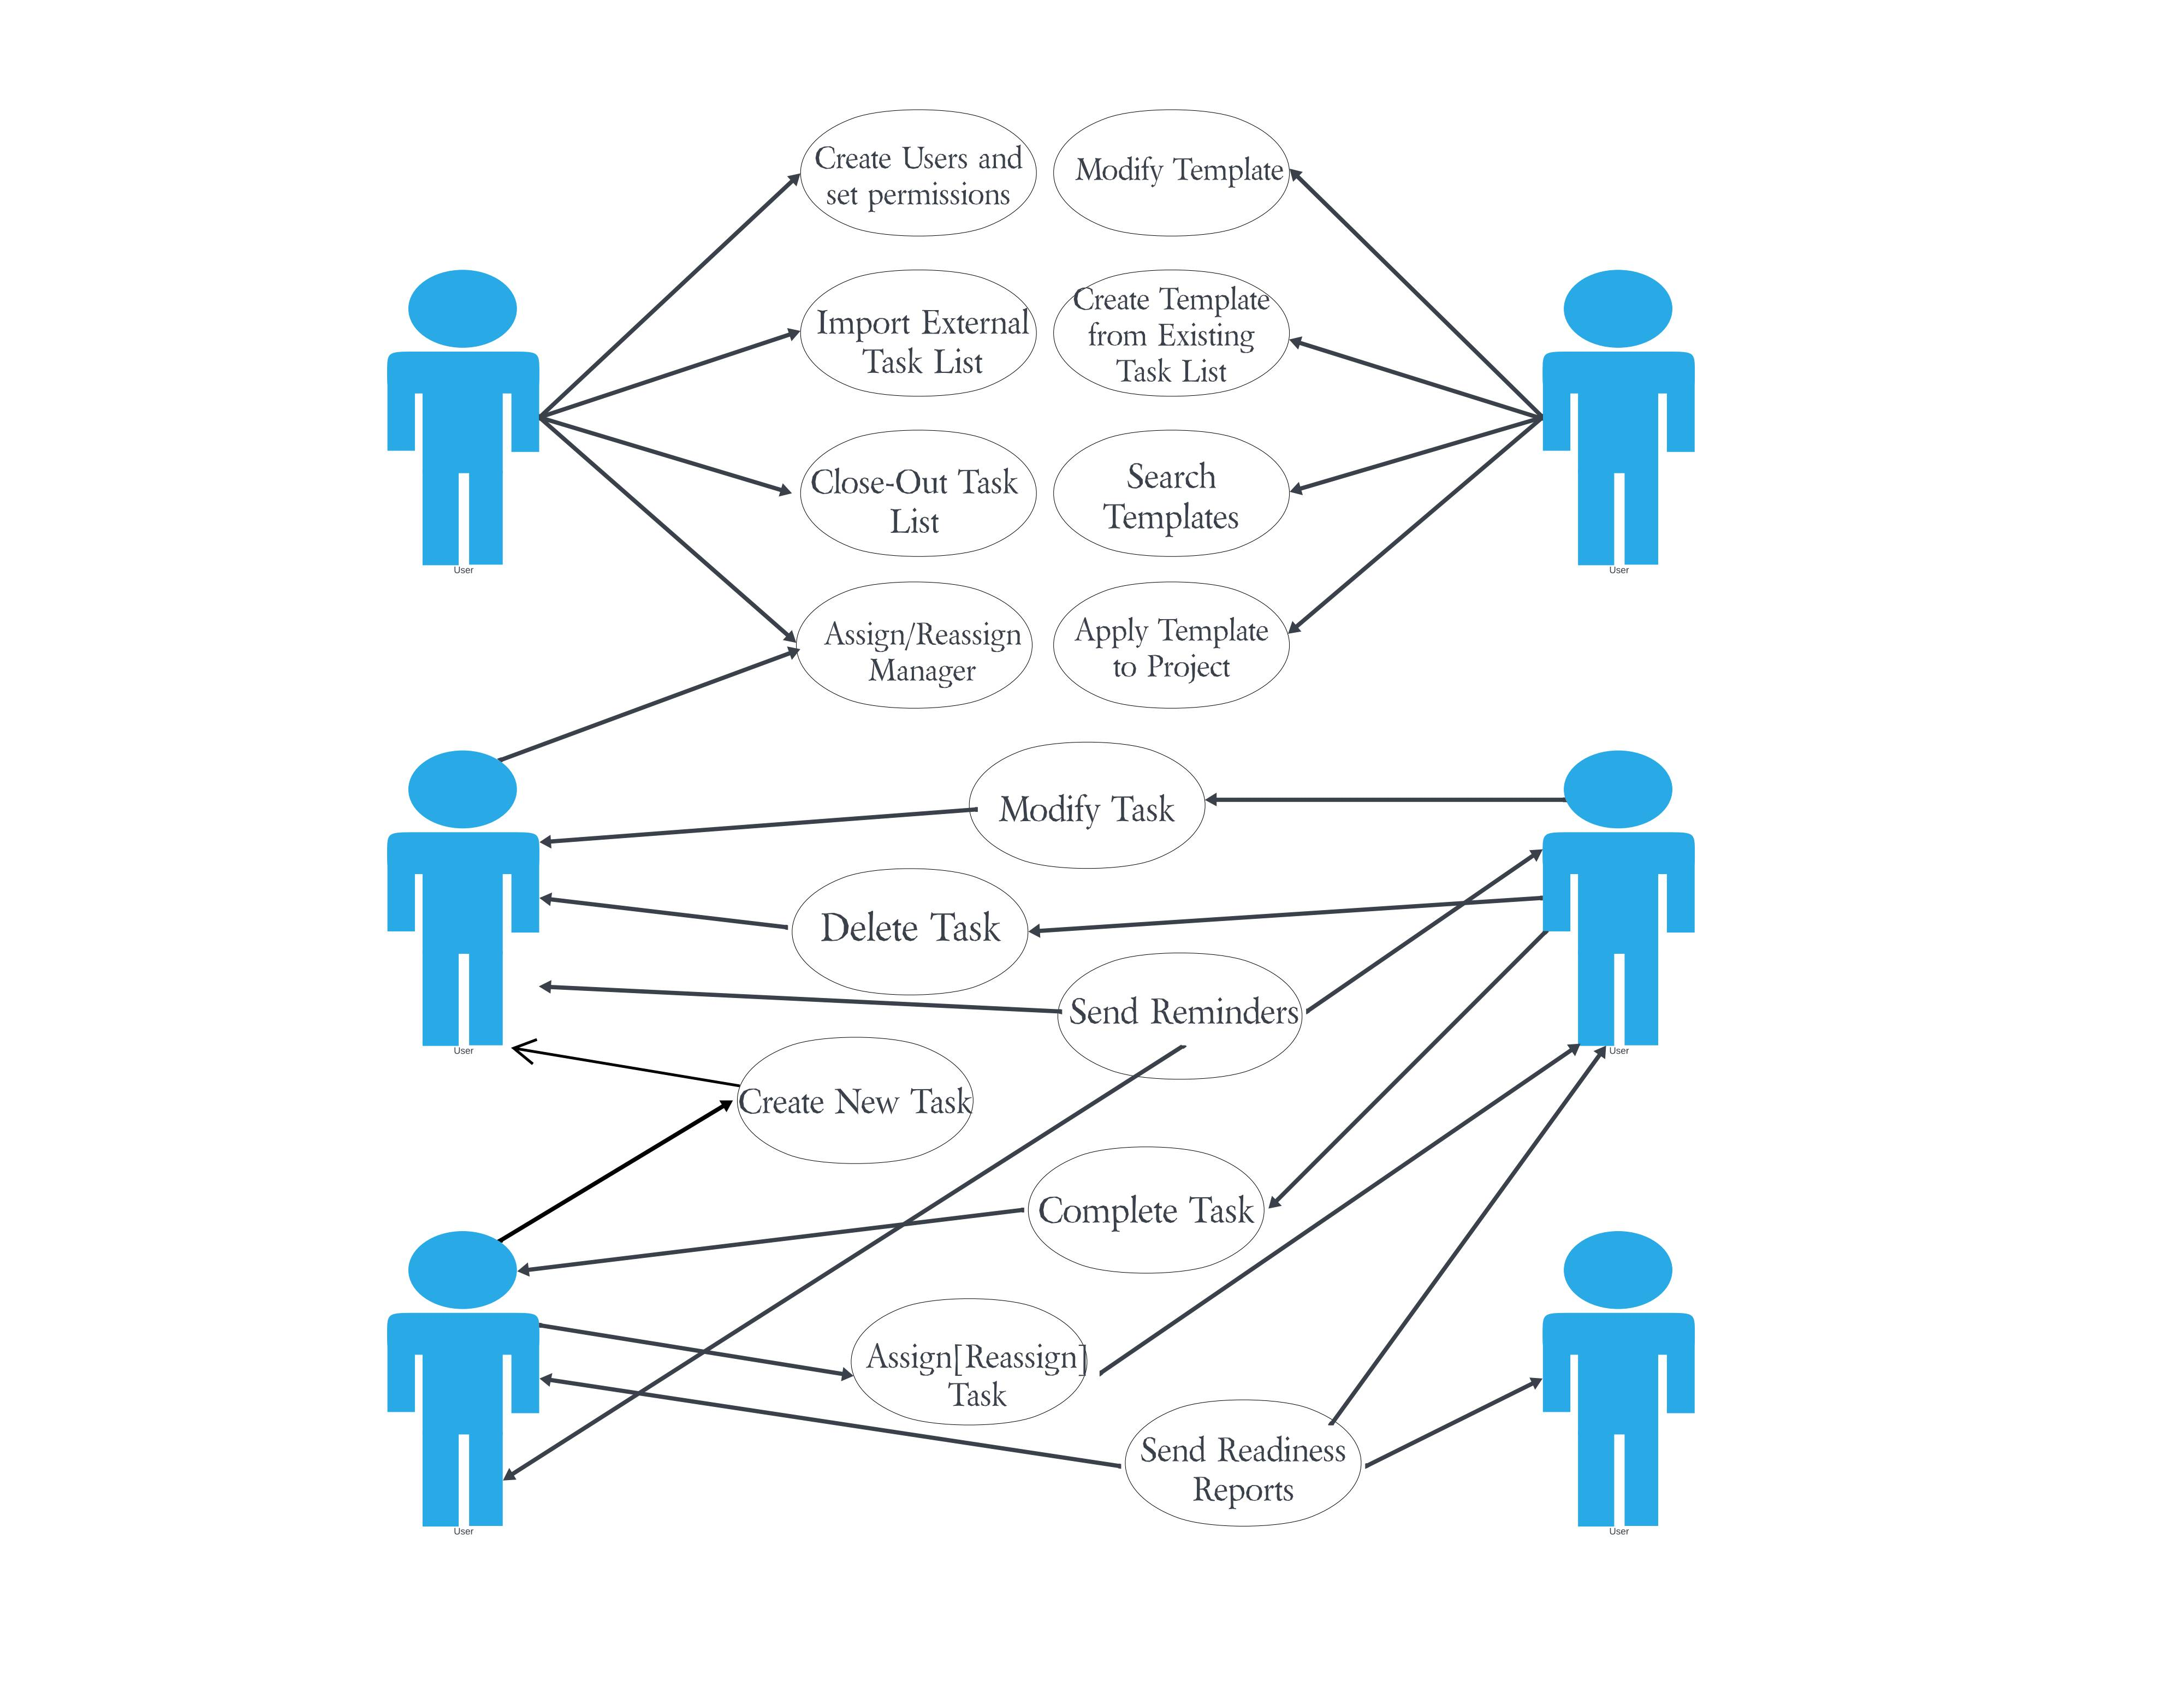

**Chapter 3: Analysis & Conceptual Design & Technical Architecture**

3.1 Technical Architecture

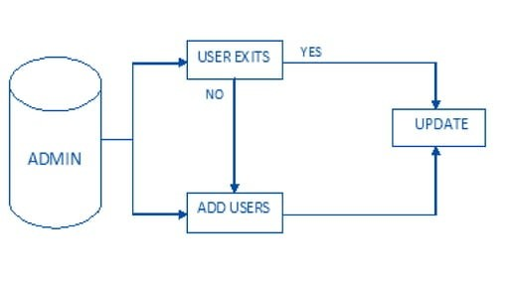

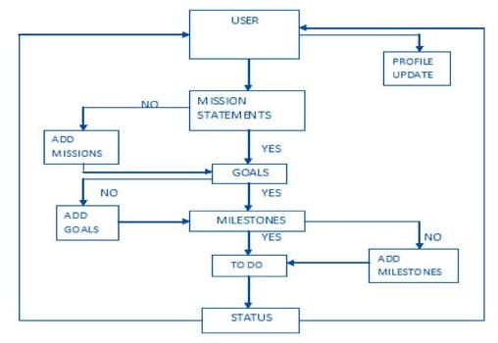

3.2 Sequence Diagrams

A sequence diagram is a type of UML (Unified Modeling Language) diagram that illustrates the interactions and order of messages between objects or components in a system. In the context of a task tracking tool, a sequence diagram can depict the interactions between various system components, such as users, tasks, and the database.

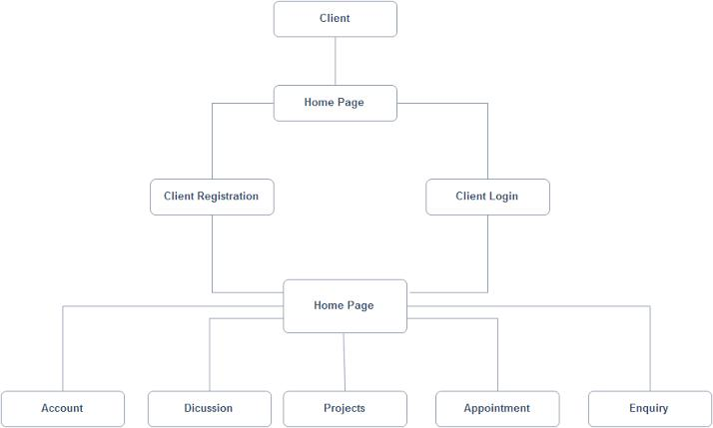

3.3 Class Diagrams

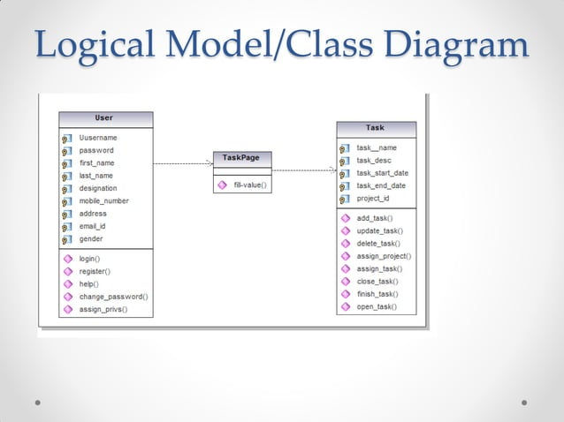

3.4 User Interface Design

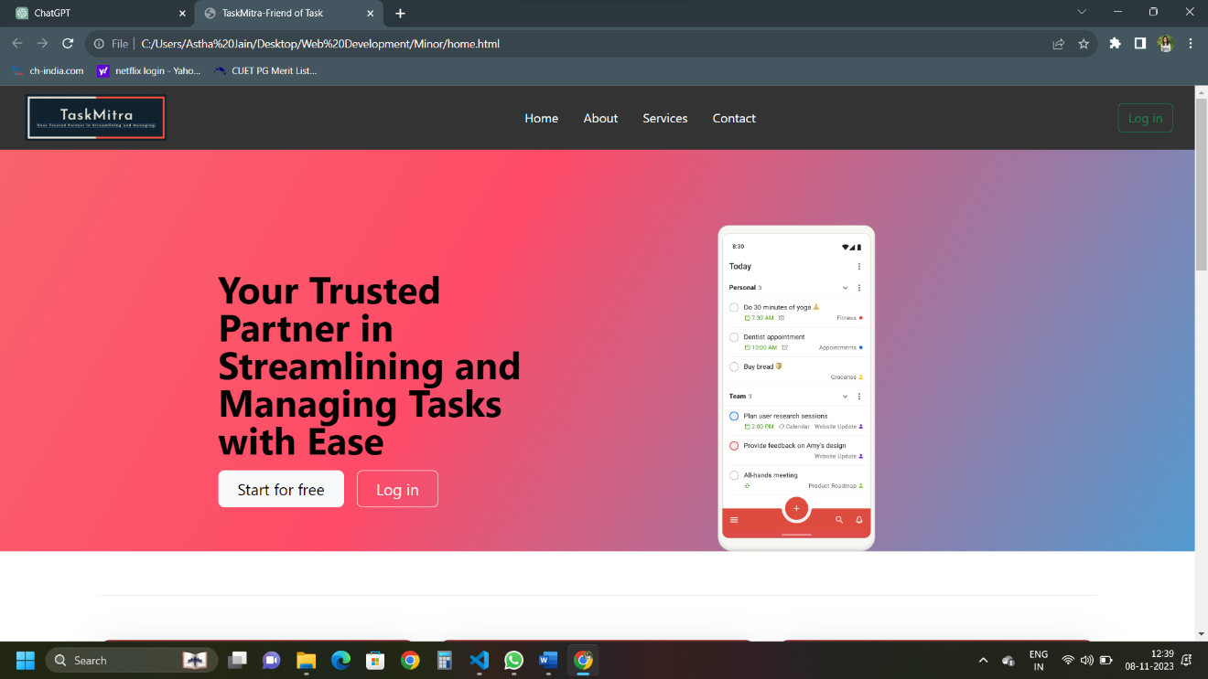

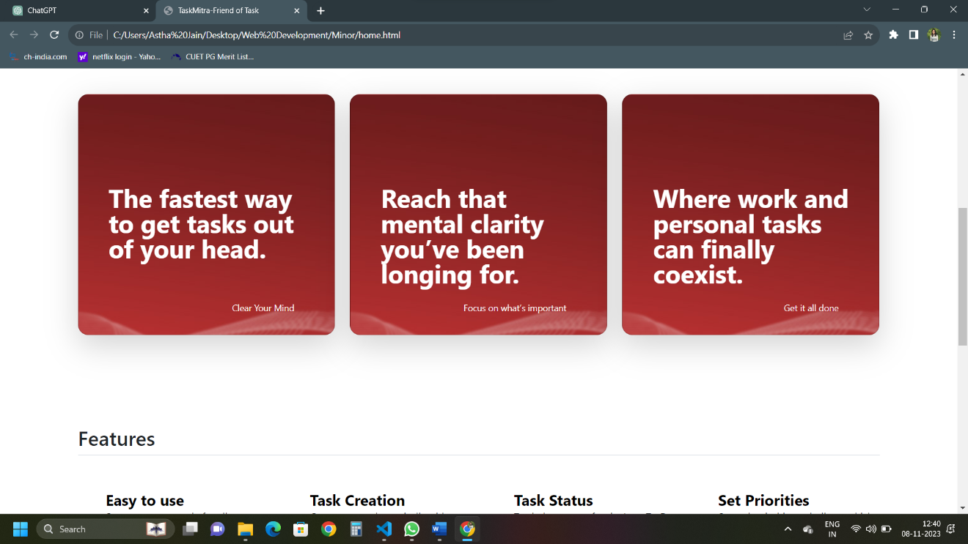

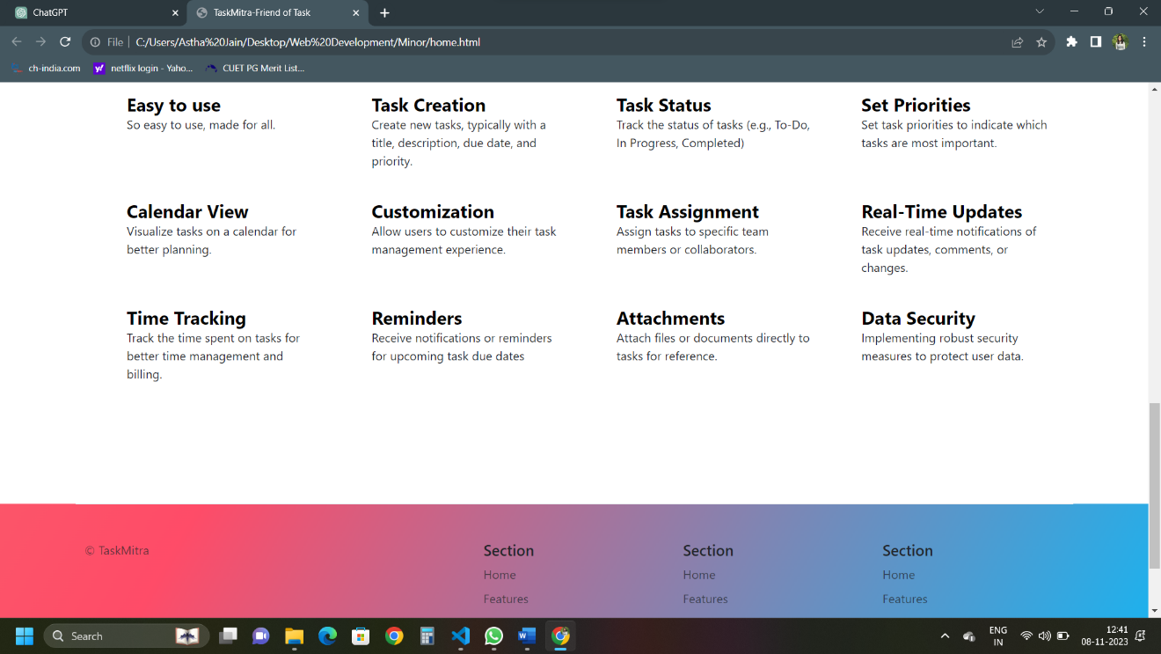

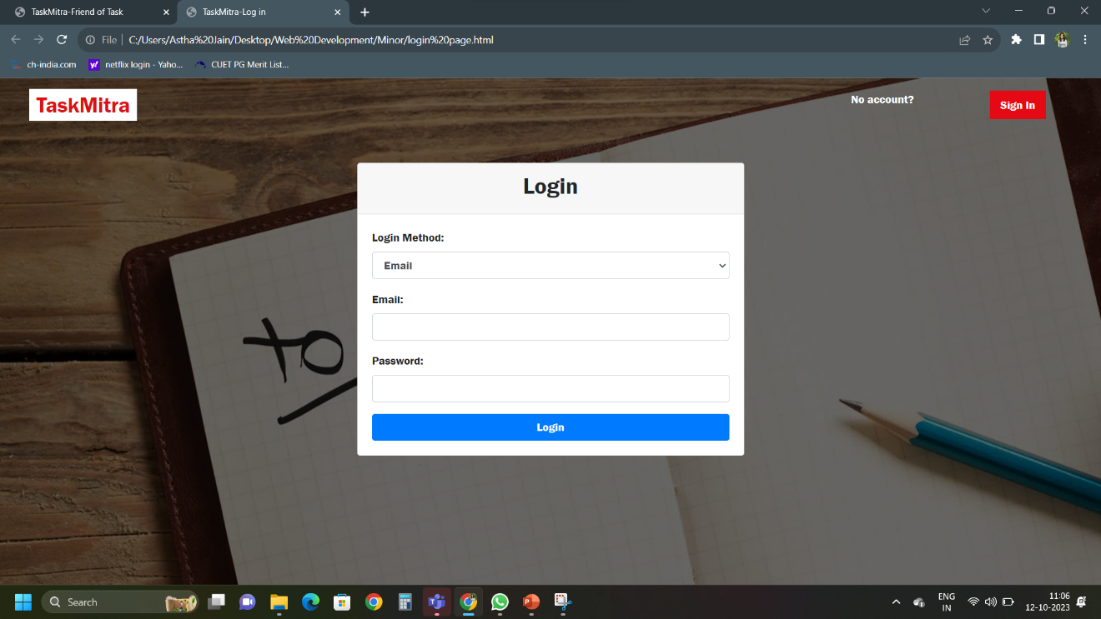

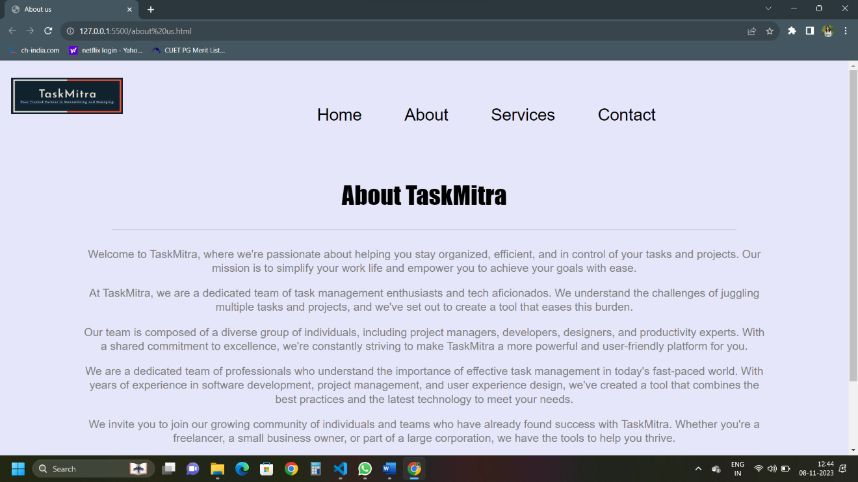

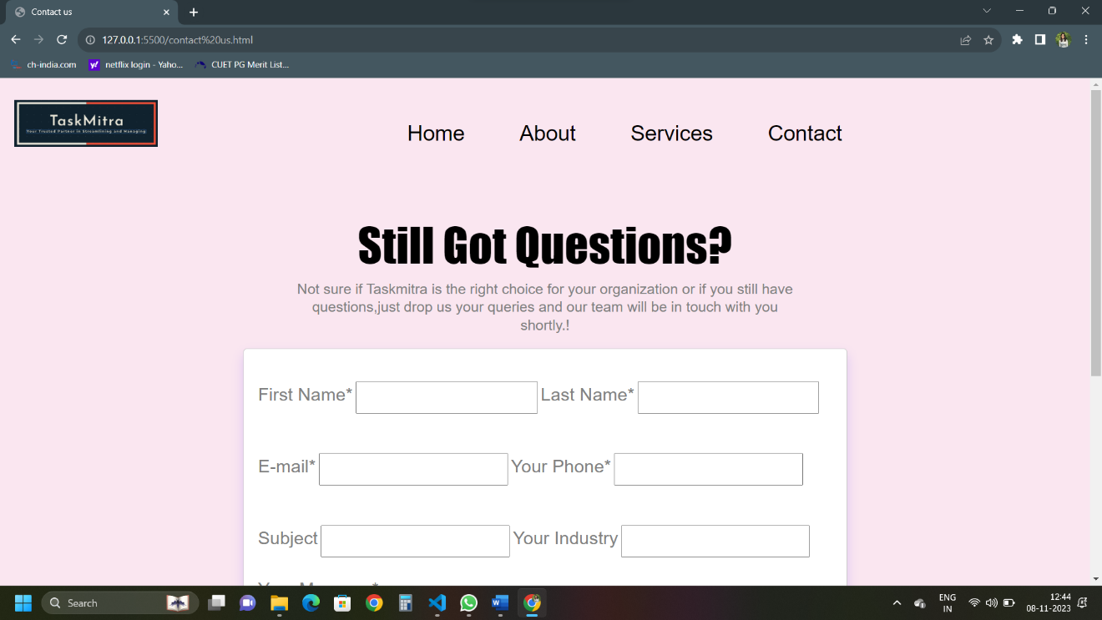

3.5 Data Design

Designing the data structure for a task tracking tool involves defining how data is organized, stored, and related within the application.

3.6.1 Schema Definitions

A schema definition for a task tracking tool typically involves defining the structure and relationships of the data that the tool will manage. Below is a simplified schema definition for a task tracking tool database:

Users:

-User ID (Primary Key)

- Username

- Email

- Password

- Profile Picture

- Role (e.g., Admin, Team Member)

Projects:

- Project ID (Primary Key)

- Project Name

- Description

- Start Date

- End Date

- Owner (User ID as a Foreign Key)

Tasks:

- Task ID (Primary Key)

- Task Name

- Description

- Priority (e.g., High, Medium, Low)

- Due Date

- Status (e.g., To-Do, In Progress, Completed)

- Assignee (User ID as a Foreign Key)

- Project (Project ID as a Foreign Key)

Comments:

- Comment ID (Primary Key)

- Comment Text

- Comment Date

- Commenter (User ID as a Foreign Key)

- Task (Task ID as a Foreign Key)

Attachments:

- Attachment ID (Primary Key)

- File Name

- File Type

- File Size

- Uploaded By (User ID as a Foreign Key)

- Task (Task ID as a Foreign Key)

3.6.2 E-R Diagram

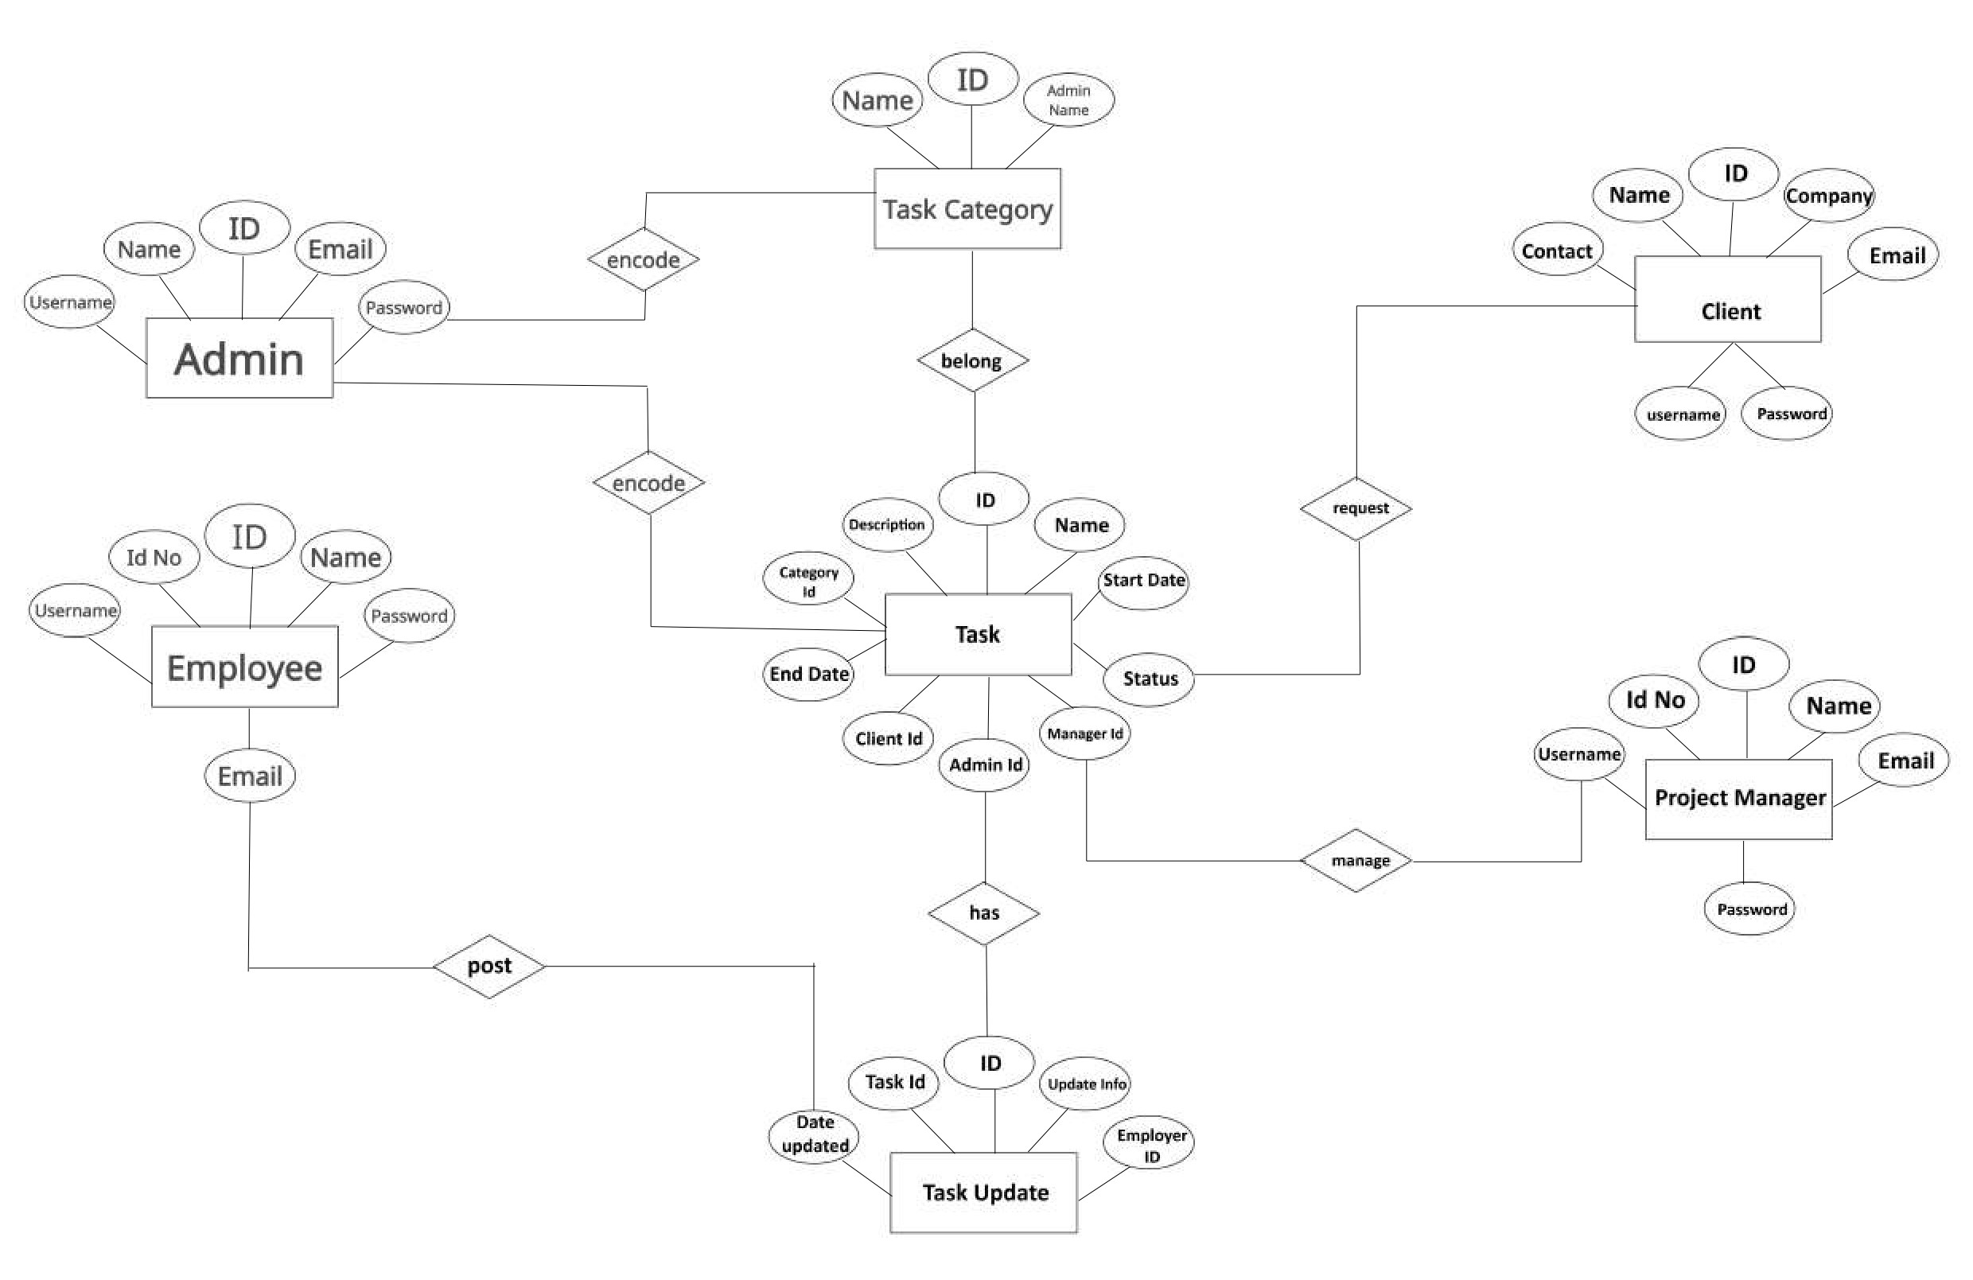

**Chapter 4: Implementation & Testing**

4.1 Methodology

4.1.1 Proposed Algorithm

In the development of our task tracking tool, we implemented an efficient and user-friendly algorithm to manage tasks and enhance productivity. The primary goal of our algorithm is to help users create, track, and prioritize tasks effectively. The algorithm is built on the following principles:

Task Organization: The algorithm classifies tasks into different categories, such as personal, work, and others, allowing users to maintain a structured list of tasks.

Priority Management: Users can assign priorities to tasks, helping them focus on the most critical items first. The algorithm uses a priority queue to ensure that high-priority tasks are always readily accessible.

Due Date Reminders: The system provides due date reminders for tasks, ensuring that important deadlines are not missed. This feature is implemented using a date-based notification system.

User Preferences: The algorithm is designed to adapt to user preferences. It learns from user behavior and suggests task management strategies based on individual working styles.

4.2 Implementation Approaches

4.2.1 Introduction to Languages, IDEs, Tools, and Technologies

For the implementation of our task tracking tool, we selected a set of languages, integrated development environments (IDEs), tools, and technologies to ensure robust and efficient performance.

Languages:We chose to develop the tool using a combination of programming languages, each serving a specific purpose:

Frontend: We used HTML, CSS, and JavaScript to create an interactive and responsive user interface.

Backend: Our backend is powered by Python, leveraging the Django framework for server-side logic and database management.

IDEs:To streamline development and collaboration, we utilized popular integrated development environments:

Frontend: Visual Studio Code (VS Code) provided a versatile environment for frontend development, with various extensions for web development.

Backend: PyCharm was our choice for Python development, offering code analysis, debugging, and version control support.

Tools and Technologies:Our choice of tools and technologies contributed to the overall functionality and usability of the task tracking tool:

Database: We employed PostgreSQL as the relational database management system to store task-related data securely.

Version Control: Git and GitHub were used for version control and collaborative development.

User Interface: Bootstrap and jQuery were integrated to enhance the user experience with pre-built UI components and interactive features.

Deployment: The tool is deployed on Amazon Web Services (AWS) for scalability and reliability.

4.3 Testing Approaches

4.3.1 Unit Testing

Unit testing is a crucial aspect of our development process. It involves testing individual components or functions of the task tracking tool to ensure they perform as intended. Below are some of the key test cases we designed for unit testing:

Test Cases:

Task Creation: Verify that tasks can be created successfully with all required attributes (title, description, priority, due date, etc.).

Task Deletion: Ensure that tasks can be deleted without affecting other tasks or causing errors.

Priority Management: Confirm that the priority assignment feature works as expected, and tasks are sorted correctly in the priority queue.

Due Date Reminders: Validate the due date reminder system by setting reminders for tasks and confirming that notifications are sent at the appropriate times.

4.3.2 Integration Testing

Integration testing focuses on testing the interactions between different components and modules of the task tracking tool to ensure that they work together harmoniously. Here are some integration test cases:

Test Cases:

User Registration and Login: Verify that the user registration process integrates seamlessly with the login functionality.

Task Categories: Ensure that tasks are categorized correctly and that changes in categories are reflected across the application.

Database Integration: Confirm that data is stored and retrieved accurately from the PostgreSQL database, and that database updates do not lead to inconsistencies.

User Preferences and Suggestions: Test the integration of the algorithm with user preferences and verify that task suggestions align with user habits and priorities.

By implementing a rigorous testing approach, we aim to deliver a robust and reliable task tracking tool that meets the needs of our users.

**Chapter 5: Results & Discussion**

In this chapter, we present the results of our task tracking tool's implementation and discuss various aspects of the system, including the user interface representation, system snapshots, and database description.

5.1 User Interface Representation

Our user interface plays a pivotal role in the overall usability and user experience of the task tracking tool. In this section, we provide a brief description of the various modules and components that constitute the user interface.

5.1.1 Brief Description of Various Modules

Dashboard: The dashboard serves as the central hub where users can view an overview of their tasks, including task categories, priority levels, and upcoming due dates.

Task Creation: This module allows users to create new tasks, specifying details such as task title, description, priority, due date, and category.

Task List: The task list module displays all tasks in an organized manner, enabling users to manage, edit, and delete tasks as needed. Tasks are color-coded based on priority for easy identification.

Category Management: Users can categorize their tasks into different categories (e.g., personal, work, etc.), providing a structured way to organize their tasks.

Task Suggestions: The system employs our proposed algorithm to suggest task management strategies based on user preferences and behavior.

User Profile: In this module, users can manage their profile information, including changing passwords, updating personal details, and configuring preferences.ser Interface Representation.

**Chapter 6. Conclusion & Future Scope**

6.1 Conclusion

In conclusion, the development and implementation of a task tracking tool offer substantial benefits to individuals and organizations seeking to enhance productivity, organization, and time management. This tool, through its streamlined approach to task management and clear prioritization, reduces stress and increases efficiency, resulting in a more focused and productive work environment.

The tool's contribution extends to effective collaboration in team settings, where it fosters accountability and transparency. By providing clear task assignment and real-time updates, it promotes teamwork and project success. Moreover, the centralization of task-related data ensures accessibility and reduces the need to search for information across multiple platforms.

Furthermore, the tool's adaptability to various workflows and industries, coupled with its commitment to continuous improvement, ensures its relevance and versatility. As technology and work environments evolve, the task tracking tool remains an indispensable resource for managing tasks and projects.

In a world where efficiency, organization, and collaboration are paramount, the task tracking tool serves as a valuable solution. Its utility in simplifying task management and promoting better time allocation positions it as a tool of significance in the pursuit of enhanced productivity and work excellence.

6.2 Future Scope

The future scope for task tracking tools is both dynamic and promising, as these tools continue to evolve to meet the changing demands of individuals and organizations. One of the most exciting prospects lies in the integration of artificial intelligence and automation, enabling AI-driven task prioritization, voice commands, and predictive analytics to streamline and enhance task management. Additionally, task tracking tools are poised to play a central role in advancing collaboration, offering advanced features for real-time communication, virtual workspaces, and even virtual reality-based team interactions, especially in the context of remote work.

As mobile and wearable technology continues to advance, future task tracking tools will expand their reach, offering seamless experiences on various devices, including smartwatches and mobile augmented reality for task management in physical environments. Data analytics and insights will become more robust, providing users with deeper insights into task performance, team productivity, and time allocation, which can inform better decision-making.

Furthermore, the integration of emerging technologies such as blockchain for enhanced security, IoT for tracking tasks in physical environments, and 5G for faster connectivity will open new horizons for task tracking tools. Customization and personalization will be at the forefront, allowing users to tailor the tool to their specific preferences and workflows. Gamification elements and incentive systems could make task completion more engaging and motivating.

With increasing concerns about data security and privacy, future task tracking tools will need to adhere to the highest standards to ensure the protection of user data. Ensuring cross-platform compatibility and considering the diverse needs of a global audience, including localization and support for multiple languages, will be paramount. Additionally, future task tracking tools may incorporate features aimed at promoting mental health and well-being, aligning with the growing emphasis on holistic wellness in the modern work environment.

In summary, the future of task tracking tools is filled with opportunities for innovation and improvement, as these tools continue to adapt to the evolving nature of work, technology, and user expectations. As they become more sophisticated and versatile, they have the potential to play a pivotal role in enhancing productivity, collaboration, and overall well-being for individuals and organizations.

3.**REFERENCES**

"Task Management Tool Proposal"

Author/Team: John Doe and Team XYZ,

Date: March 1, 20XX ,Description: The initial proposal outlining the purpose

and objectives of the task management tool project.

"Task Manager System Architecture and Design"

Author/Team: Alan Johnson and Development Team Bravo

Date: May 10, 20XX, Description: Overview of the tool's architectural design

and component details

"Technology Stack for Task Management Tool"

Author/Team: Development Team Bravo

Date: May 30, 20XX ,Description: A list of technologies and tools used in the

project, including programming languages and frameworks.

"Task Management Tool Database Schema"

Author/Team: Database Team Charlie

Date: June 20, 20XX, Description: Documentation of the database structure

and data model.

"Task Management Tool Project Management Plan"

Author/Team: John Doe and Project Team Alpha

Date: March 15, 20XX, Description: Details of the project management

methodology, timeline, and workflow.

**Appendix A:** Project Synopsis

**Appendix B:** Guide Interaction Report (*Dully Signed by Guide)

**Appendix C:** User Manual